**DAILY ONLINE ACTIVITIES SUMMARY**

|  |  |  |  |  |  |  |  |  |
| --- | --- | --- | --- | --- | --- | --- | --- | --- |
| Date: | 26/05/2000 | | | | | Name: | Jyothi B R | |
| Sem & Sec | IV-A | | | | | USN: | 4AL18CS030 | |
| Online Test Summary | | | | | | | | |
| Subject | | Design and Analysis of Algorithms | | | | | | |
| Max. Marks | | 30 | | Score | | | 27 | |
| Certification Course Summary | | | | | | | | |
| Course | Programming Essentials in Python | | | | | | | |
| Certificate Provider | | | Cisco Virtual Academy | | Duration | | | 2hrs |
| Coding Challenges | | | | | | | | |
| Problem Statement1. Python Program to Check if a Number is a Palindrome  2. The permutations of the string are | | | | | | | | |
| Status:Completed | | | | | | | | |
| Uploaded the report in Github | | | | | Yes | | | |
| If yes Repository name | | | | | https://github.com/alvas-education-foundation/jyothi_b_r | | | |
| Uploaded the report in slack | | | | | Yes | | | |

Online Test Details: (Attach the snapshot and briefly write the report for the same)

Certification Course Details: (Attach the snapshot and briefly write the report for the same)

Coding Challenges Details: (Attach the snapshot and briefly write the report for the same)

ONLINE TEST DETAILS:

The online test was from module 2. There were 30 questions which contains 30 mcq questions and the duration were 30 minutes. The questions were optimal and easy. The score that I received was 27/30.

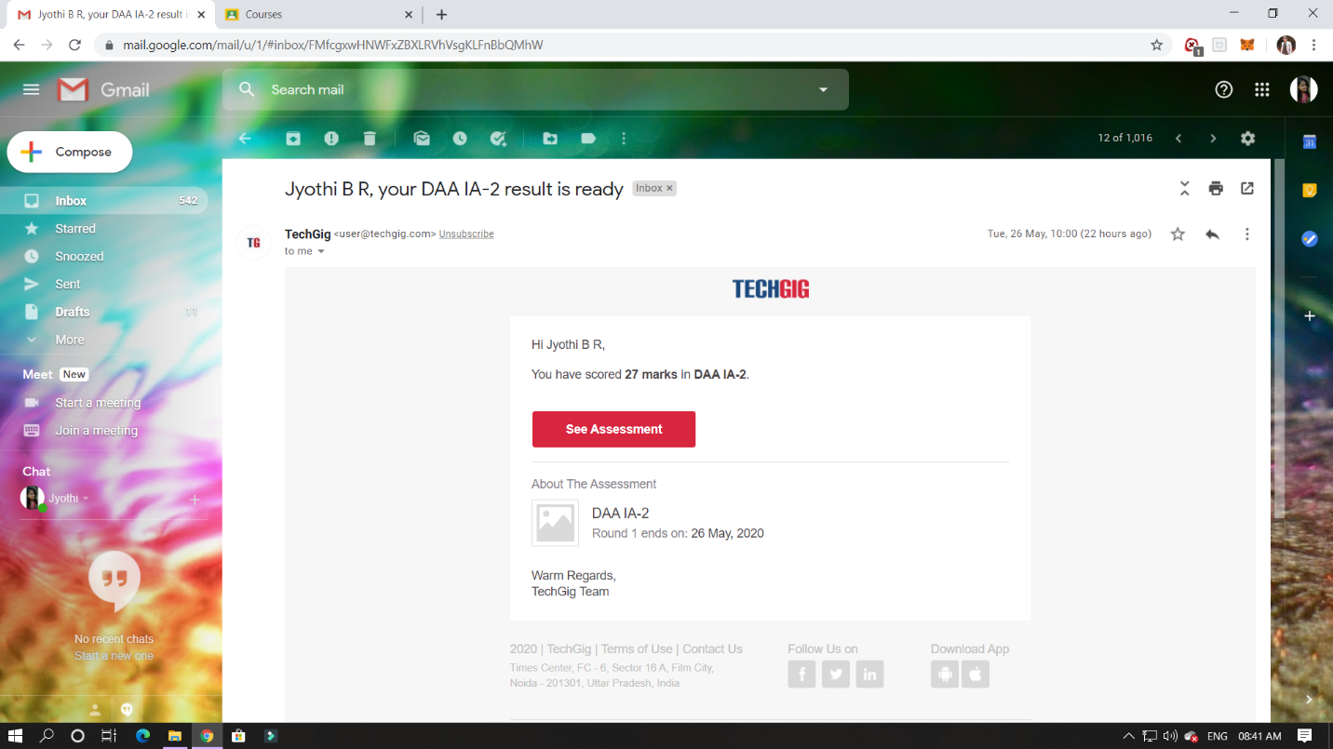

CERTIFICATION COURSE DETAILS:

Programming Essentials in Python :

List in Lists: two – dimensional arrays.

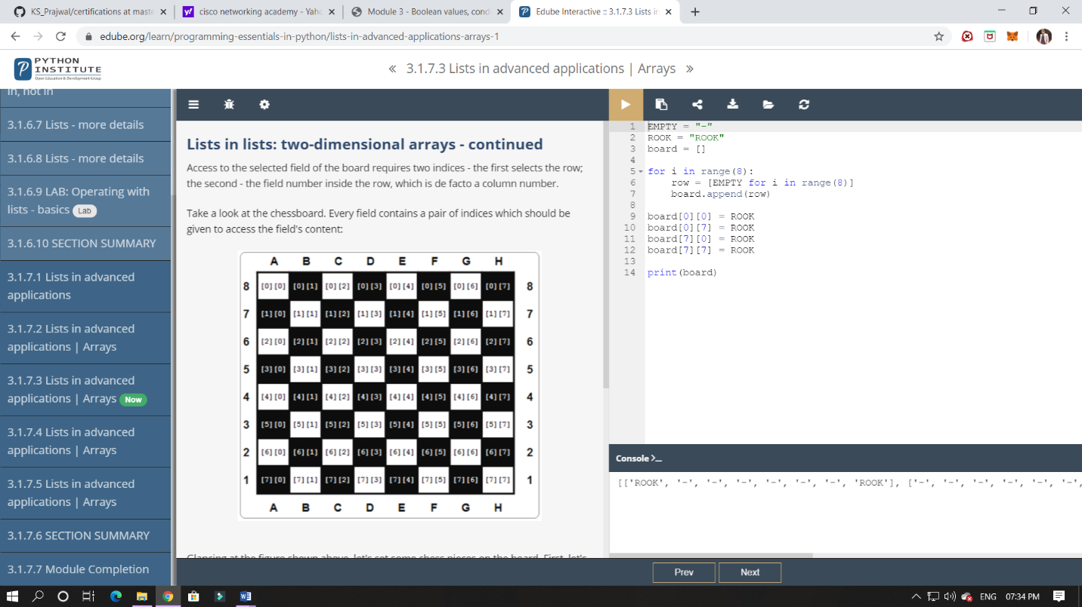

ONLINE CODING:

1.Python Program to Check if a Number is a Palindrome

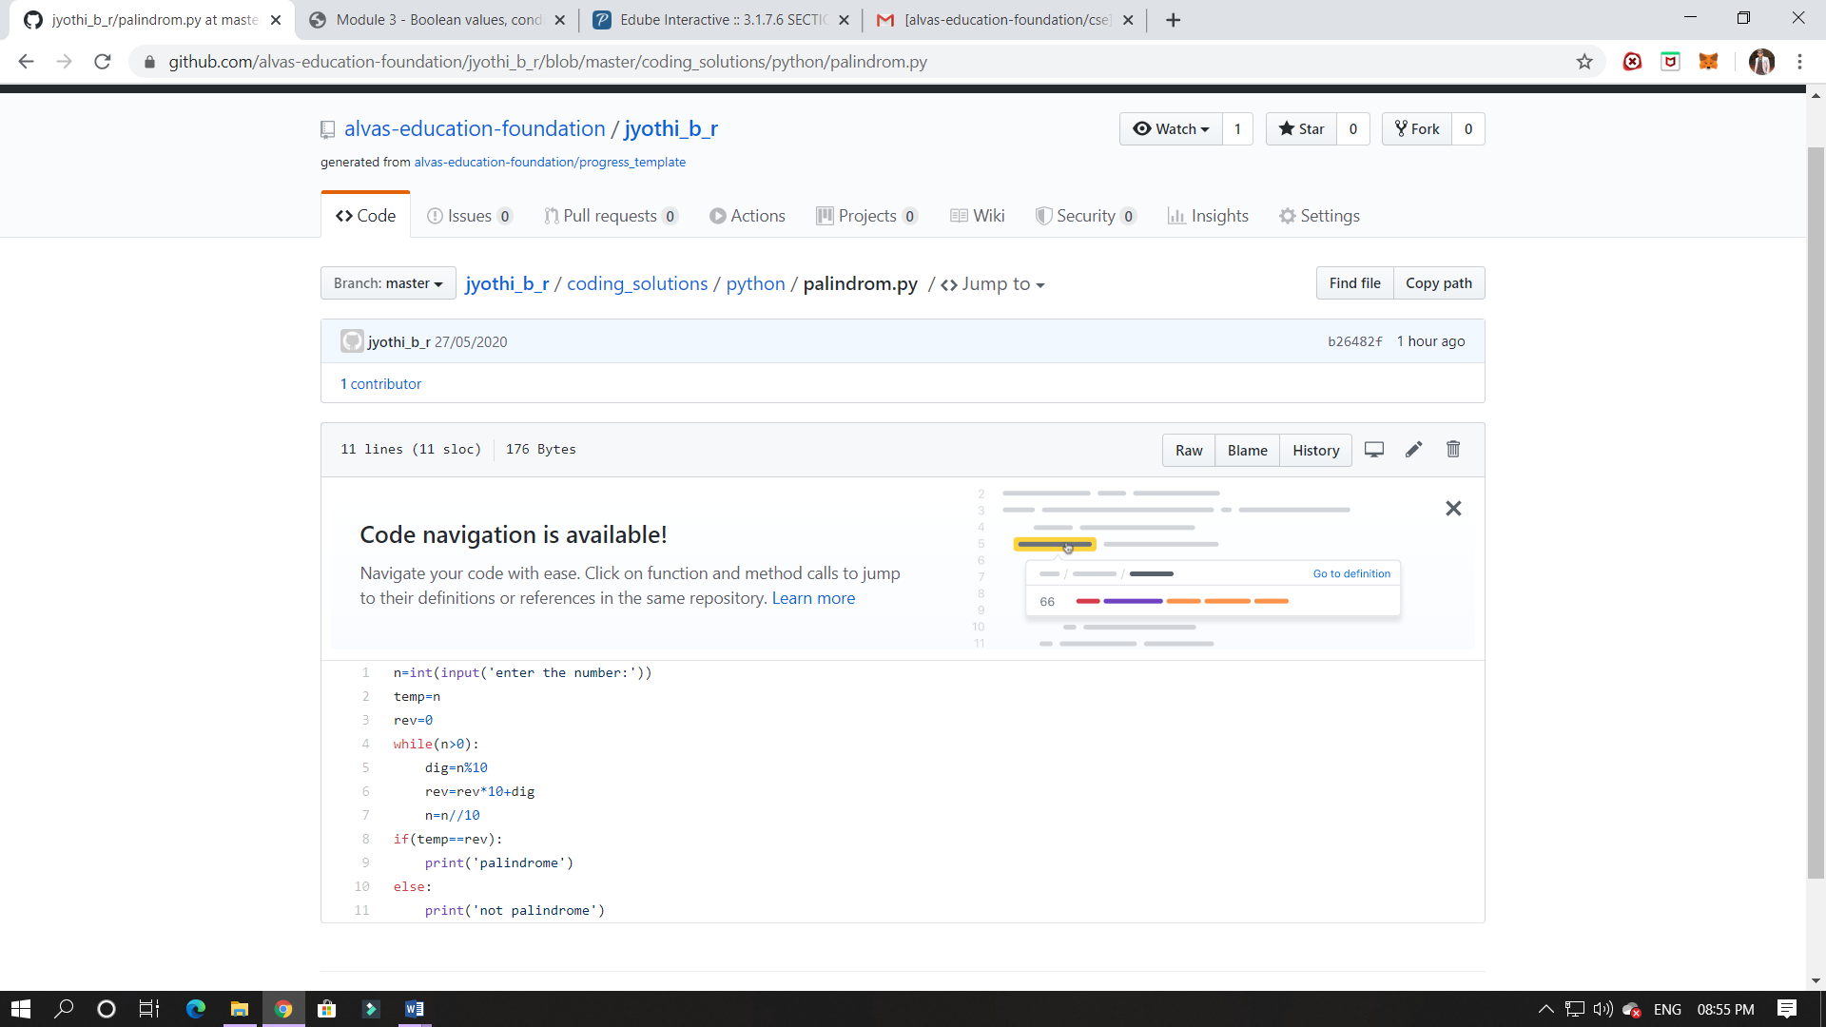

2. The permutations of the string are :  
abcd abdc acbd acdb adcb adbc bacd badc bcad bcda bdca bdac cbad cbda cabd cadb cdab cdba dbca dbac dcba dcab dacb dabc

